# Business Planning for Dorothy

May,2020

## Introduction

### Background

As a graduate student from the University of Melbourne, Dorothy, one of my besties friends, wants to open up a coffee shop around Melbourne university or near the Melbourne City Centre.(As Melbourne university locates closely near the city Centre, so the business planning sounds plausible.)

Dorothy is a heavy coffee person, and Melbourne is a well-known city for its famous coffee beans and special coffee taste. There are so many coffee shops around Melbourne city, and each of them has special taste and attracts many customer. And for many tourists and even local people, they tend to search from Foursquare websites for high-rated coffee shops.

### 1.2 Problem

As it is her first business start-ups, Dorothy want to make as through analysis as possible before she started to open the coffee shop. Now the question she want to solve are listed below:

Know more about Foursquare by search coffee shops around Melbourne university for Dorothy knows those shops well. The search results will let Dorothy know data well and build a basic understanding on how data can help her make business decisions.

Know whether coffee shop is a good choice for her by checking the venue trends around Melbourne Uni and Melbourne City.

### 1.3 Interest

Obviously, Dorothy is quite interested in this report. For other people who want to open a coffee shop around Melbourne Uni or Melbourne Centre would be interested in the content listed in the report.

## Data source clarifying

For it's a start-up business, Dorothy can gain basic understanding from website like Foursquare, where numerous people rates on shops, leave tips and even upload photos. Thanks to the big data analysis given by Foursquare, not only can people like Dorothy can obtain specific venue information efficiently, but also the venue trends can be gained, which is very important for entrepreneurs like Dorothy.

So, basically, we first set Foursquare information as the only data source. More practically, Dorothy should search for more industry information, financially or non-financially, once she decided which industry to go into.

## Methodology

### 3.1 Search for coffee shops around Melbourne Uni

Based on the business description, Dorothy want to start a coffee shop around Melbourne Uni. The first thing Dorothy want to know is who are the main rivalries. By setting the Melbourne Uni geolocation first, we call the Foursquare API to get the venue information around Melbourne Uni. For Dorothy has a specific taste in coffee, we add the ‘coffee’ string information into the query sentence.

This is the start point for our data analysis, where Dorothy can build a basic understanding of who are the main rivalries and start to consider the competitive advantage for those best coffee shops.

### 3.2 Search for highest-rating coffee shop to know competitive advantage

We now have the best coffee shops around Melbourne Uni. It’s time for us to explore who is the best and why is it. First, we search ratings for each companies located in Carlton, where Melbourne Uni locates. For the highest rating one, we analysis its tips feature for Seven Seeds.

### 3.3 Check whether coffee is in its upside industry business trend

To make small business long-lasting, we need to consider whether coffee industry is in its upside trends, whether around Melbourne Uni or near Melbourne Centre.

We first check the trending venue around Melbourne Uni and later check the venue trend near Melbourne Centre.

## Data observation

* 1. Coffee shops around Melbourne Uni

## 

We get a data frame including 19 coffee shops around Melbourne Uni.

* 1. Check coffee shops located in Carlton to narrow down analysis scope

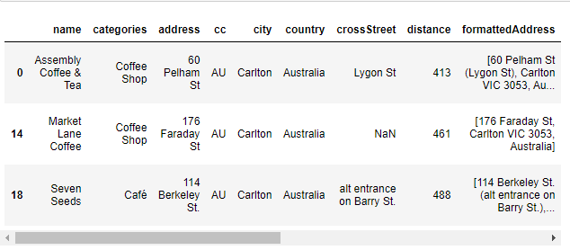

By narrowing down to coffee shops locates in Carlton, we get a data frame with three coffee shops. They are ‘Assembly Coffee & Tea’,’ Market Lane Coffee’,’ Seven Seeds.

And there relatively position shows below.

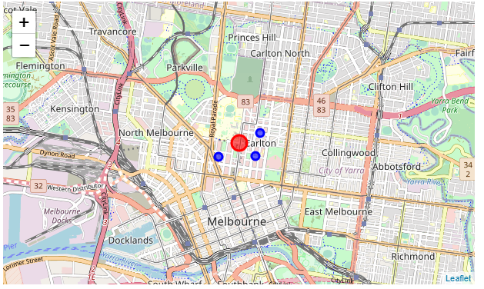

* 1. rating analysis

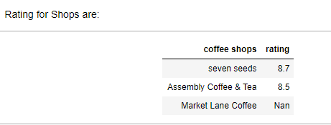

For seven seeds gets the highest rating, we dig further for the tips analysis.

* 1. Tips analysis for Seven Seeds

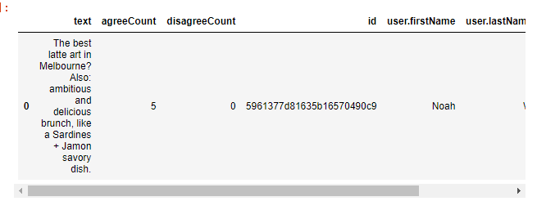

Based on the Tips request from Foursquare, we know that Seven seeds is pronounce for its art atmosphere and delicious brunch provided.

* 1. Trending analysis around Melbourne Uni and Melbourne Centre

we want to know whether coffee shop is of worthy for investment. We first explore the venue trending around Melbourne Uni, but nothing found. Then we turn to Melbourne Centre, and find that of the 30 trending venues listed, 7 of them are coffee or café related, demonstrating that coffee is still popular and of bright future.

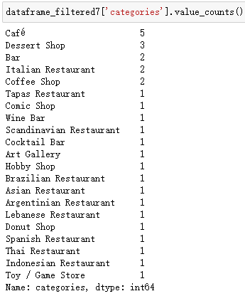

## Conclusion

Based on the analysis above, we can conclude that:

First, coffee shop is worth for investing. Dorothy could start her business around Melbourne Uni or locate near Melbourne Centre both, but Melbourne Centre more is preferable for it has clear upside trending.

Second, for a coffee shop, Dorothy should not only focus on the taste of coffee or coffee beans itself, but also pay more attention on decorations or other food provided like the quality of brunch provide. As demonstrated by the Seven seeds, people come to there probably just because of the artist decoration, not just for special coffee taste.